1. **Is there a difference in wholesale prices for buyers of different countries?**

**Answer:**There is no siginificant difference in discount caused by country factor.We first test the discount between 2 countries under different information conditions (no information,market information,social information,both information,All information) in the following manners:

$$discount=α+βcountry (1)$$

The country is a binary variable which equals zero if the country is South Africa and equals one if the country is United states.The esitimation results are presented in Table 1(The relevant code can be attained in “country-condition.py”).

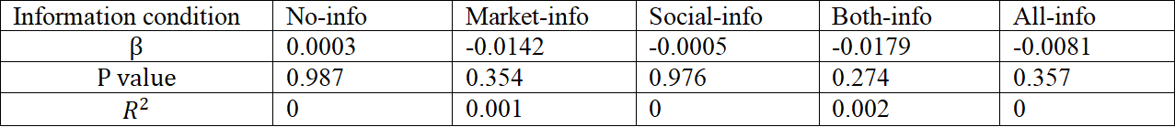

Table 1

It clearly presents that under all kinds of condition the coefficient of country and the $R^{2}$ is not siginificant,and the P value is never lower than 0.005 which indicates that there is no strong difference between the data from US and data from SA.

2.  **Do suppliers price discriminate against buyers based on buyers’ races?**

**Answer:**White buyers suffer from the price discrimination .Under the no information condition ,we first calculate the average discount received by each race and do t test in pairs.The results are presented in Table 2(The relevant code can be attained in “Pvalue-race.py”).

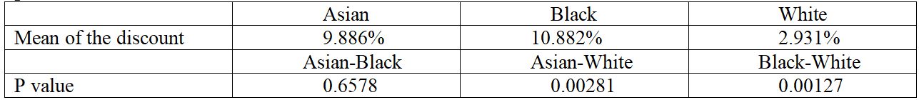

Table 2

You can intuitively see that Asian and Africa receive a similar average discount and both of them are significantly higher than discount giving to White.The p value then validates the point(the threshold of the significance decision is 0.005 which means that when p value exceeds 0.005 we do not think the difference is significant). To find what factors should be considered as the control variables when making regression,we test several effects in the following manners:

$$discount=α+β1GoodSupplierYears+β2TransactionLevel+β3No_Transaction+β4ResponseRate+β5No_ofReviews +β6Listed_Price (2)$$

The esitimation results are presented in Table 3.(The relevant code can be attained in “multiple_variables_regression.py”).

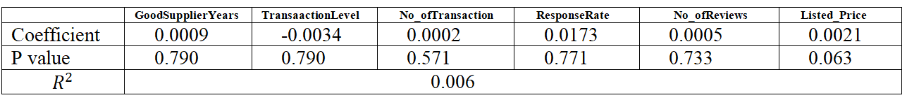

Table 3

The only factor having a great impact on discount is the Listed_Price.So next we will dismiss other factors and only choose the Listed_Price as the control variable.To see the discount difference among the three races formally,we test in the following manners for 3 times:

$discount=α+βrace+γListed_Price (3)$

The race is a binary variable which equal 1 or 0 and only represent 2 races every time to escape the use of dummy variable.The esitimation results are presented in Table 4.(The relevant code can be attained in “race _discrimination _ regression.py”).

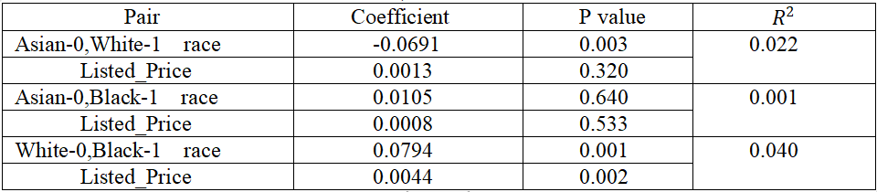

Table 4

The result is consisitent with previous speculation that the white tends to receive a much lower discount than asian and black and there is no significant difference between asian and black .

3. **Can Market Info reduce the wholesale price quoted by suppliers?**

**Answer:**Market info can reduce the quoted price for all races.We first make a comparison between the discount received under no info condition and discount received under market info condition.The result are presented in Table 5.(The relevant code can be attained in “Pvalue-race.py”).

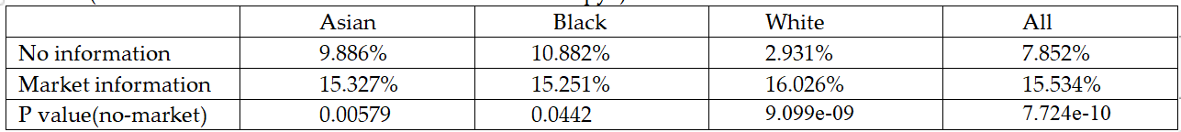

Table 5

It can be clealy observed that in each race the the discount under market condition are significantly higher than the discount under no information which means that the quoted price are reduced.To see the discount difference between no information condition and market information condition formally,we test in the following manners for each race:

$discount=δ+αinfo+βListed_Price (4)$

The info is a binary variable which equals 0 in the no-info condition and equals 1 in the market-info condition.The result are presented in Table 6.(The relevant code can be attained in “market regression(race).py”).



Table 6

In all races,the market-info is a significant factor to the discount elevation.And among the 3,the discount giving to white is the most sensitive to the market information leading a 0.074 cofficient of determination($R^{2}$).

1. **Can Social Info reduce the wholesale price quoted by suppliers?**

**Answer:** Social info can only reduce the quoted price for white and black but can not decline the price for asian.We first make a comparison between the discount received under no info condition and discount received under social info condition.The result are presented in Table 7.(The relevant code can be attained in “Pvalue-race.py”).

|  |  |  |  |  |
| --- | --- | --- | --- | --- |
|  | Asian | Black | White | All |
| No information | 9.886% | 10.882% | 2.931% | 7.852% |
| Social information | 8.168% | 15.857% | 9.721% | 11.281% |
| P value(no-social) | 0.422 | 0.0341 | 0.00417 | 0.0101 |

Table 7

For white and black,the increase in discount is obvious after customer getting social information.However for asian,the discount even has a little decline instead of improvement.Then we test this formally by using the equation(4) for each race.The info is a binary variable which equals 0 in the no-info condition and equals 1 in the social-info condition.The result are presented in Table 8.(The relevant code can be attained in “social regression(race).py”).

|  |  |  |  |  |  |
| --- | --- | --- | --- | --- | --- |
|  | $$α$$ | $$β$$ | P value-info | P value-listed_price | $$R^{2}$$ |
| Asian | -0.0172 | 6.604e-05 | 0.423 | 0.957 | 0.001 |
| Black | 0.0487 | 0.0017 | 0.038 | 0.220 | 0.013 |
| White | 0.0676 | 0.0029 | 0.004 | 0.045 | 0.027 |

Table 8

For white and black,the coefficient of social information is significant and has a positive correlation with discount. But the that corrlation is not obvious when the race is asian.

**5.Can Market Info reduce the wholesale price discrimination for buyers of different races?**

**Answer:**The market info could reduce the wholesale price discrimination for buyers of different races.We have concluded that the discrimination mainly exists towards white .Therefore we detect the difference between aisan and white and between black and white under the market information condition by the equation(3).The race is a binary variable.The esitimation results are presented in Table 9.(The relevant code can be attained in “marketinfo - racediscrimination.py”).

|  |  |  |  |
| --- | --- | --- | --- |
| Pair | Coefficient | P value | $$R^{2}$$ |
| Asian-0,White-1 race | 0.0077 | 0.677 | 0.01 |
| Listed_price | -0.0022 | 0.049 |
| Black-0,White-1 race | 0.0077 | 0.684 | 0.00 |
| Listed_price | 4.955e-05 | 0.965 |

Table 9

The white is not a sensitive factor which generates significant difference to the discount anymore.So we can draw the conclusion that the price discrimination can be mitigated by market information.

6. **Can Social Info reduce the wholesale price discrimination for buyers of different races?**

**Answer:**Social info can not reduce the wholesale price discrimination completely.We test this under social information condition by the equation(3).The race is a binary variable.The esitimation results are presented in Table 10.(The relevant code can be attained in “socialinfo - racediscrimination.py”).

|  |  |  |  |
| --- | --- | --- | --- |
| Pair | Coefficient | P value | $$R^{2}$$ |
| Asian-0,White-1 race | 0.0157 | 0.473 | 0.004 |
| Listed_price | 0.0015 | 0.256 |
| Black-0,White-1 race | -0.0614 | 0.006 | 0.017 |
| Listed_price | -2.679e-05 | 0.984 |

Table 10

The discount giving to white is similar to the discount giving to asian but is still sigificantly lower than the discount giving to black.That means under the social market information,you could observe the price discrimination towards to both asian and white who receive a much lower discount than black.